Test Project
  - Web Technologies
  - PHP and JavaScript Module

Submitted by:

Sebastian Häni – CH (Independent Test Project Designer)
Cyril Wanner – CH (Independent Test Project Designer)
Patrick Zahnd – CH (Independent Test Project Designer)

Contents
Contents 2
Introduction 3
Description of project and tasks 3
Phase one – PHP 3
Database design 3
Organizer interface 4
Organizer login and logout 5
Event management 6
Ticket management 10
Session management 12
Channel management 14
Room management 15
Room capacity 16
Attendee API 17
Events overview 18
Event detail 19
Attendee login and logout 20
Event registration 21
Phase two – JavaScript 22
API Setup 22
Introduction 23
Events list 24
Event agenda 25
Session detail 27
Event registration 27
Attendee login 31
Notes 32
Submission Instructions to the Competitor 33
Equipment, machinery, installations, and materials required 34
Marking Scheme 35

Introduction

介绍
The agency responsible for organizing the WorldSkills Conferences needs a new web application helping them to manage the events and allowing attendees to sign up and see all information they need. It should be dynamically built so that it can later be shared with other member organizations which means that multitenancy is an important requirement.
Because this application will grow over time, important requirements are covered by automated tests.
世界技能组织大会机构需要一个新的Web应用程序来帮助他们管理事件，并允许与会者注册并查看他们需要的所有信息。它应该是动态构建的，以便以后可以与其他成员组织共享，这意味着多重任务处理是一个重要的需求。
由于此应用程序将随着时间而成长，因此重要的需求将被自动化测试覆盖。

Description of project and tasks

项目和任务说明
The project is split into two phases:
项目分为两个阶段：
- phase one (morning, 3 hrs) for building the backend parts (admin interface and REST-API) using PHP (framework) and database
- 第一阶段（早上3小时），使用PHP（框架）和数据库构建后端部件（管理界面和REST-API）
- phase two (afternoon, 3 hrs) for building the frontend parts (attendee interface) using HTML/CSS/JS (framework) and the REST-API provided for phase two.
- 第二阶段（下午3小时），使用HTML/CSS/JS（框架）和为第二阶段提供的REST-API构建前端部件（与会者界面）。

Phase one – PHP

第一阶段-PHP

Database design数据库设计
- Use your database (dbYY_competitor_day2) and import the schema/dump provided
- 使用你的数据库（dbYY_competitor_day2）并导入提供的架构/转储
- Extend your database to be able to store (do not modify/extend any existing table except if it is specifically noted as they will be resetted before every test run)
- 扩展您的数据库以便能够存储（不要修改/扩展任何现有表格，除非特别指出它们会在每次测试运行之前被重新设置）
  - Event ratings 事件评级
    - Attendees should be able to comment and rate events they have attended
    - 与会者应该能够对他们参加的事件进行评分和评级。
    - Rating should be a full number between 1 and 5, where 1 is the lowest and 5 the highest rating
    - 评级应为1到5之间的整数，其中1是最低的，5是最高的。
    - The date and time of the rating should be registered
    - 应登记评级日期和时间。
  - Session ratings 活动评级
    - Additional to the event rating, attendees should be able to rate sessions they have attended
    - 除了事件评级外，与会者应该能对他们参加的活动进行评级。
    - Rating should be a full number between 1 and 5, where 1 is the lowest and 5 the highest rating
    - 评级应为1到5之间的整数，其中1是最低的，5是最高的。
    - The date and time of the rating should be registered
    - 应登记评级日期和时间。
- Your additional tables need to follow the third normal form.
您的附加表需要遵循第三范式。

Organizer interface组织者界面
Create an organizer interface (Server Side Rendered using a PHP Framework) using the templates provided to
使用所提供的模板来创建组织者界面（使用PHP框架呈现的服务器端）
- manage events, sessions, channels, rooms and tickets (create, read, update)
- 管理事件、活动、频道、房间和门票（创建、读取、更新）
- create a bar chart to see the occupancy rates of all rooms
- 创建条形图以查看所有房间的入住率
- create dynamic ticket prices
- 创建动态票价
- support multiple tenants
- 支持多个租户
Because different organizers will use this backend, keep security in mind. It should not be possible to access events of other organizers or update events of other organizers.
因为不同的组织者将使用这个后端，请确保安全性。不应有访问其他组织者事件或更新其他组织者活动的可能。

Organizer login and logout 组织者登录和注销
Because registering as a new organizer is not within the scope of this project, please update the first two organizers in the provided dump so that it is possible to log in with the following credentials:
由于注册为新组织者不在此任务范围内，请更新所提供的转储中的前两个组织者，以便使用以下凭据登录：
- Email: demo1@worldskills.org Password: demopass1
- Email: demo2@worldskills.org Password: demopass2
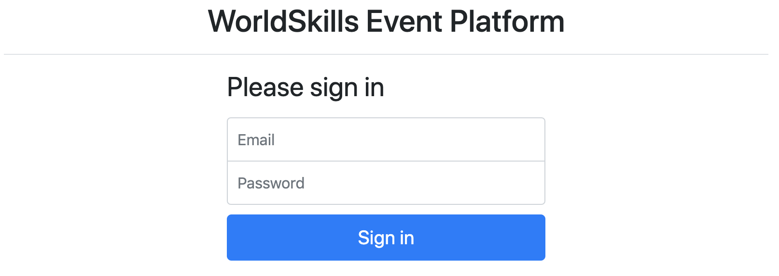
Specification:
规范：
Feature: A1 – Log in and log out as an organizer: As an organizer, I would like to log in and log out to the event platform so that I can access the functionality of the platform.
功能：A1–以组织者身份登录和注销：作为组织者，我希望登录和注销到事件平台，以便访问平台的功能。
Scenario: A1a - Organizer login ok
场景：A1a-组织者登录正常
Given I am on the "login" page
假设我在“login”页面
When I enter the specified email and password for an organizer
当我为组织者输入指定的电子邮件和密码时
And press the "Sign in" button
按下“Sign in”按钮
Then I am forwarded to the organizer area
然后我被转到组织者区域
And organizator name and "Sign out" button become visible in the header
组织者名称和“Sign out”按钮在标头中可见
And page "Manage events" becomes visible
页面“Manage events”变为可见
Scenario: A1b - Organizer login fail
场景：A1b-组织者登录失败
Given I am on the "login" page
如果我在“login”页面
When I enter a wrong email and password combination for an organizer
or use login information of an attendee instead of an organizer
当我为组织者输入错误的电子邮件和密码组合时或者使用与会者的登录信息而非组织者时
And press the "Sign in" button
然后按下“Sign in”按钮
Then I stay on the "login" page
然后我停留在“login”页面
And I see an error message "Email or password not correct"
我将看到一条错误消息“Email or password not correct”

Scenario: A1c - Organizer logout
场景：A1c-组织者注销
Given I am logged in
如果我登录了
When I press the "Sign out" button
当我按下“Sign out”按钮时
Then I am forwarded to the "login" page
然后我被转到“login”页面
And organizator name and logout button and admin functions disappear
组织者名称、注销按钮和管理者功能消失
And I cannot reach the previous page by going back
我回不去上一页

Event management 事件管理
Organizers should be able to save all information about an event and its sessions in the database. Every organizer account can only see and edit its own events. The organizer may have zero or many events.
组织者应该能够将事件及其活动的所有信息保存在数据库中。每个组织者帐户只能查看和编辑自己的事件。组织者可能有零个或多个事件。
Specification:
规范：
Feature: A2 - Manage events: As an organizer I want to manage events so attendees can find events
功能：A2 - 管理事件：作为组织者，我希望管理事件，以便与会者可以找到事件。
Scenario: A2a – List all events
场景：A2a–列出所有事件
Given I am logged in
如果我登录了
And I am on the "Manage events" page
我在“Manage events”页面
Then I see a list of all events created by the current organizer sorted
ascendingly by their date
然后我看到当前组织者创建的所有事件已按日期升序排列
And I see the total number of registrations for every event
然后我看到每个事件的注册总数

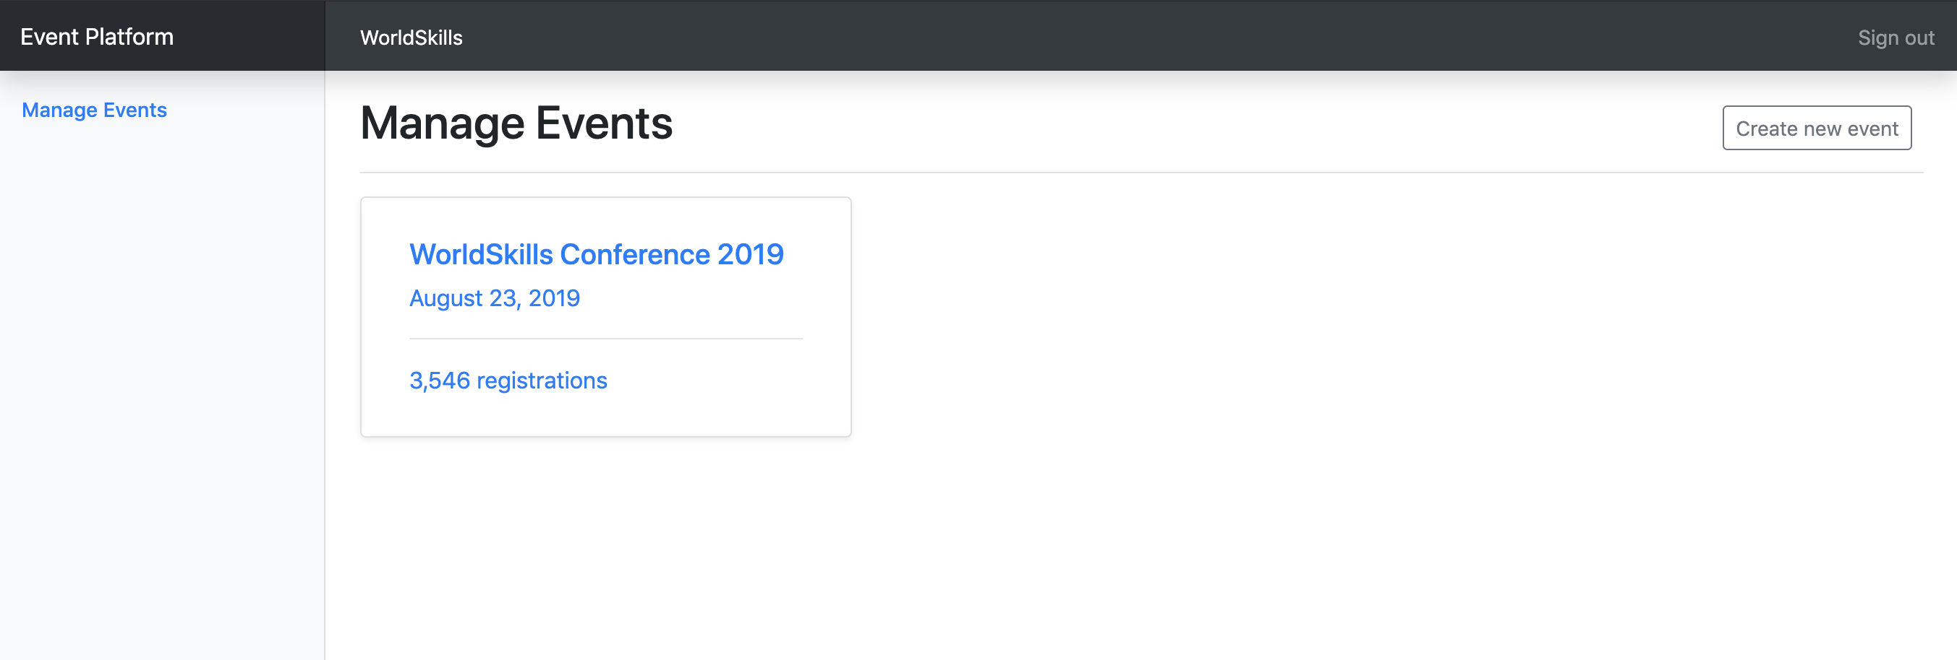

Scenario: A2b - Show form for new event
场景：A2b-显示新事件的表单
Given I am logged in
如果我登录了
And I am on the "Manage events" page
我在“Manage events”页面
When I press "Create new event"
当我按下“Create new event”时
Then a form to enter event information appears
然后会出现一个输入事件信息的窗体

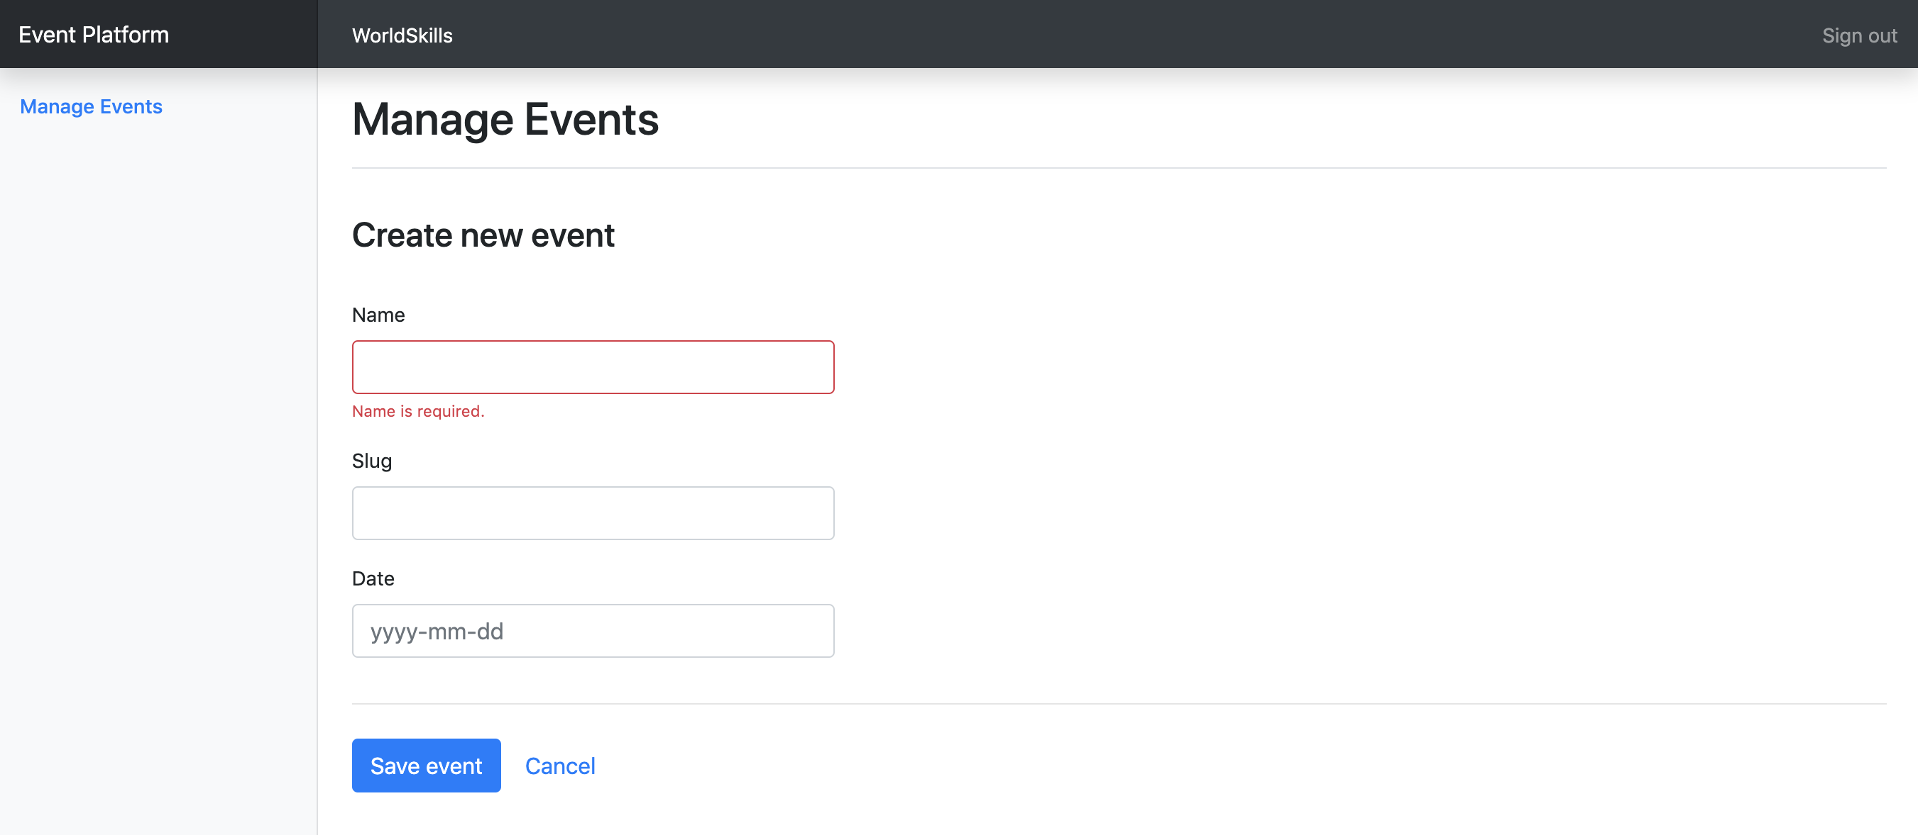

Scenario: A2c - Enter information for a new event
场景：A2c-输入新事件的信息
Given a form to enter event information is shown
假设显示了输入事件信息的表单
When I enter info for the event (all fields required)
当我为事件输入信息时（所有字段都是必需的）
And I press "Save event"
我按下“Save event”
Then the event is saved into the database
然后事件将被保存到数据库中
And I am redirected to the detail page for the newly created event
我被重定向到新建事件的详细信息页面
And a success message "Event successfully created" is shown
并显示成功消息“Event successfully created”

Scenario: A2d – Enter already used slug for a new event
场景：A2d–为新事件输入已使用的别名
Given a form to enter event information is shown
假设显示了输入事件信息的表单
When I enter info for the event and use a slug which is already used by
another event of the same organizer
当我输入事件信息并使用一个已被同一组织者的另一个事件使用的别名
And I press "Save event"
我按下“Save event”
Then the event is not saved into the database
则事件不会被保存到数据库中
And an error message "Slug is already used" is shown
并显示错误消息“Slug is already used”（已使用别名）。
And my previously submitted input data is not lost
我之前提交的输入数据不会丢失

Scenario: A2e – Enter invalid slug for an event
场景：A2e–为事件输入无效的别名
Given a form to enter event information is shown
假设显示了输入事件信息的表单
When I enter an invalid slug for the event
当我为事件输入一个无效的别名时
And I press "Save event"
我按下“Save event”
Then the event is not saved into the database
则事件不会保存到数据库中
And an error message "Slug must not be empty and only contain a-z, 0-9 and
'-'" is shown
显示错误信息” Slug must not be empty and only contain a-z, 0-9 and '-'"
Scenario: A2f - Show form for updating event
场景：A2f-显示更新事件的表单
Given I am logged in
假设我登录了
And I am on the detail page of an event
我在事件的详细页面上
When I press "Edit event"
当我按下“Edit event”时
Then a form to update event information appears
然后会出现一个更新事件信息的表单

Scenario: A2g – Update event information
场景：A2g–更新事件信息
Given a form to update information of an existing event
假设有一个更新现有事件信息的表单
When I change the prefilled old event information to new values
当我将预先填充的旧事件信息更改为新值时
And I press "Save event"
我按下“Save event”
Then the updated event is saved into the database
然后更新的事件将被保存到数据库中
And I am redirected to the detail page for the updated event
我被重定向到更新事件的详细信息页面
And a success message "Event successfully updated" is shown
并显示成功消息“Event successfully updated”（事件成功更新）

Scenario: A2h – Show event detail
场景：A2h–显示事件详细信息
Given I am on the "Manage events" page
假设我在“Manage events”页面上
And I click on an event in the list
我单击列表中的一个事件
Then I am forwarded to the detail page on this event
然后我被转到这个事件的详细信息页
And can see all basic information as well as all relations to the available rooms, channels, sessions and tickets
可以看到所有的基本信息以及现有房间、频道、活动和门票

Ticket management 票务管理
For each event, organizers want to create different ticket types. Tickets can have, but don’t need, one validity rule which can be one of:
对于每个事件，组织者希望创建不同的门票类型。门票可以有但不是必须有下列有效规定之一：
- only purchasable until a given date (e.g. book before July 30, 2019 for an early bird ticket)
- 仅在指定日期之前可购买（例如，2019年7月30日之前订票）
- only a defined amount of tickets is available (e.g. max 50 VIP tickets)
- 仅提供规定数量的门票（例如最多50张VIP门票）
Please check existing records in the provided dump to see how validity rules should be stored.
请检查所提供的转储中的现有记录，以了解如何存储有效性规定。
Specification: 规范
Feature: A3 – Manage tickets: As an organizer I want to manage tickets that attendees can buy in the frontend
功能：A3–管理门票： 作为组织者，我想管理与会者可以在前端购买的门票
Scenario: A3a – Show form for new ticket
场景：A3a—显示新票的表单
Given I am on the detail page of an event
假设我在一个事件的详细页面上
And I press "Create new ticket"
我按下“Create new ticket”
Then a form to enter ticket information appears
然后会出现一个用于输入门票信息的表单
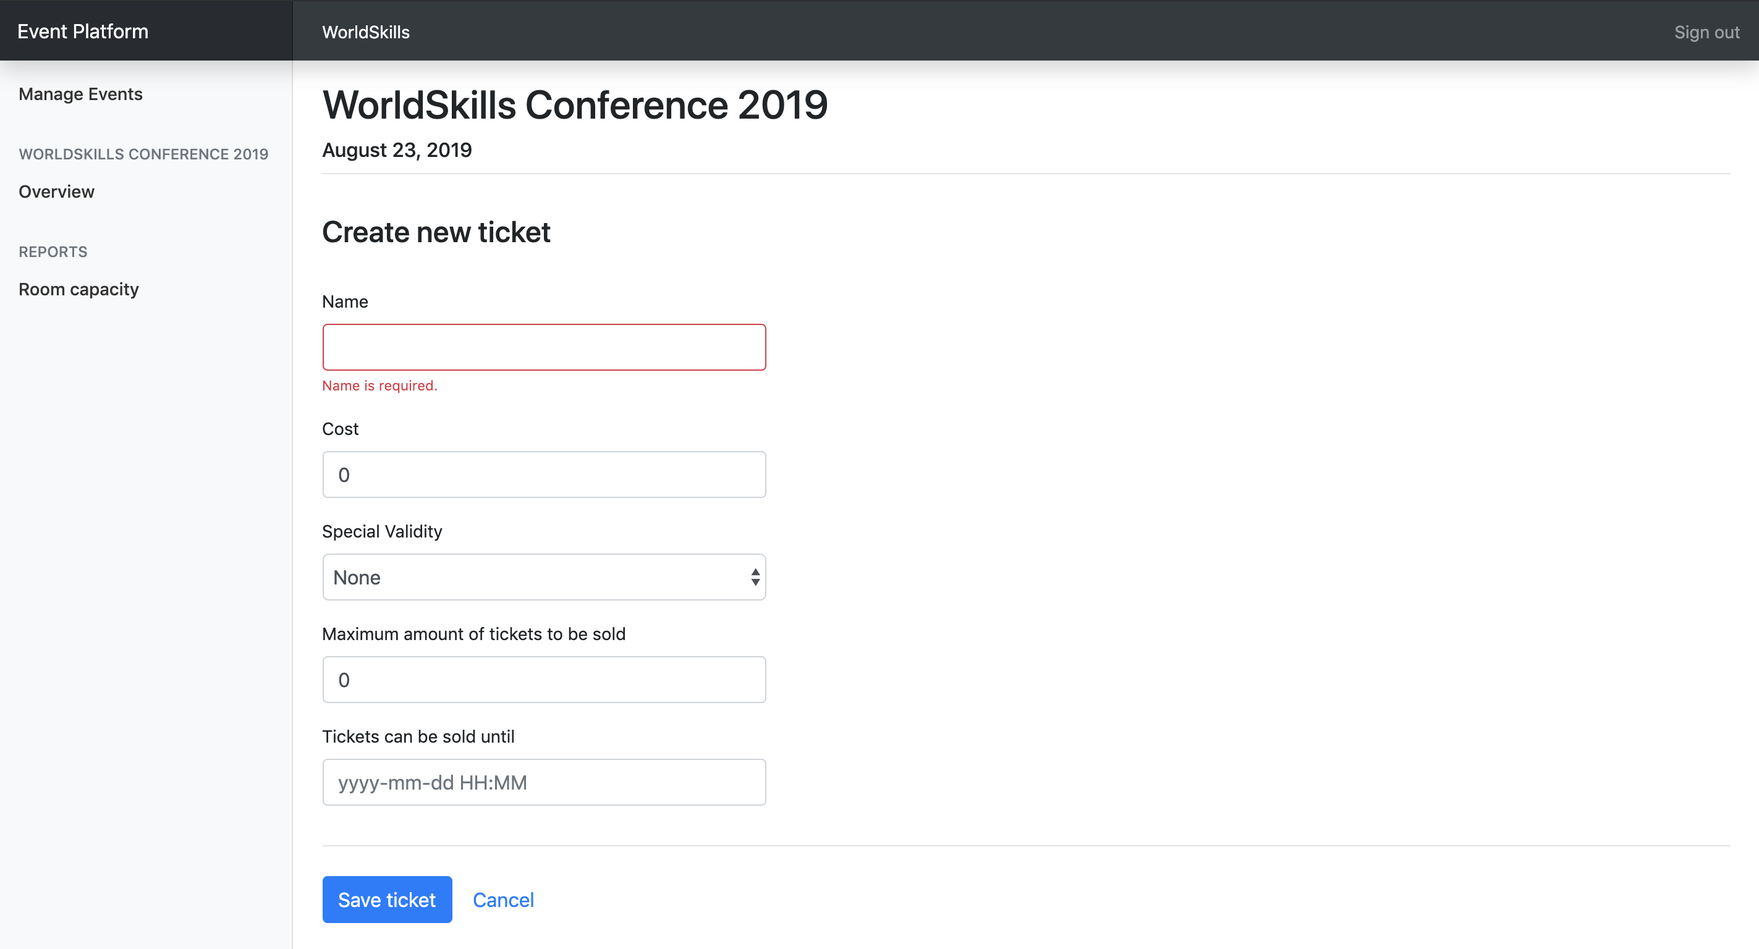

Scenario: A3b – Enter information for a new ticket
场景：A3b–输入新票的信息
Given a form to enter session information is shown
假设显示了一个输入活动信息的表单
When I enter information for the ticket (name and cost field are required, also any field that is related to the selected special validity rule)
当我为门票输入信息时（必须填写“名称”和“成本”字段，以及与所选特殊有效性规则相关的任何字段。）
And I press "Save ticket"
我按下“Save ticket”
Then the ticket is saved into the database
然后门票就被保存到数据库中
And I am redirected to the detail page of the event it is assigned to
我被重定向到它被分配到的事件详细页面上
And a success message "Ticket successfully created" is shown
并显示成功消息“Ticket successfully created”（已成功创建票据）

Session management活动管理
For every event, organizers want to be able to list the current sessions and have the possibility to create new ones. Sessions are always assigned to a room which can not have another session during that time. Sessions are one of these two types:
对于每个事件，组织者都希望能够列出当前的所有活动，并有可能创建新的活动。活动总是分配给一个房间，该房间在此期间不能进行其他活动。活动是以下两种类型之一
- talk: A speaker presents a talk. Talks are included in the conference ticket and do not cost extra.
- 会话：演讲者演讲。会话包含在会议门票中，不额外收费。
- workshop: A speaker holds a hand-on workshop with its attendees. Workshops can cost extra.
- 研讨会：演讲者与与会者一起参与实践研讨会。研讨会可能会额外收费。
Specification: 规范：
Feature: A4 – Manage sessions: As an organizer I want to manage sessions that attendees can sign up for
功能：A4–管理活动：作为组织者，我想管理与会者可以注册的活动
Scenario: A4a – Show form for new session
场景：A4a–显示新活动的表单
Given I am on the detail page of an event
假设我在一个事件的详细页面上
And I press "Create new session"
我按下“Create new session”
Then a form to enter session information appears
然后会出现一个输入活动信息的表单
Scenario: A4b – Enter information for a new session
场景：A4b–输入新活动的信息
Given a form to enter session information is shown
假设显示一个输入活动信息的表单
When I enter information for the session (all fields， except cost, required)
当我为活动输入信息时（所有字段都是必需的, 成本除外）
And I press "Save session"
我按下“Save session”
Then the session is saved into the database
然后将活动保存到数据库中
And I am redirected to the detail page of the event it is assigned to
And a success message "Session successfully created" is shown
我被重定向到它被分配到的事件详细页面上，并显示成功消息“Session successfully created”

Scenario: A4c – Enter invalid information for a new session – room booked
场景：A4c–为新活动输入无效信息 – 预订房间
Given a form to enter session information is shown
假设显示了一个输入活动信息的表单
When I choose a room which already has another session at the same time
当我选择一个房间，而该房间在同一时间已被另一个活动占据时
And I press "save session"
我按“Save session”
Then the session is not saved into the database
那么活动就不会保存到数据库中
And an error message "Room already booked during this time" is shown
并显示错误消息”Room already booked during this time”(“房间在此期间已预订”)
And my previously submitted input data is not lost
我之前提交的输入数据不能丢失

Scenario: A4d – Show form for updating session
场景：A4d–显示更新活动的表单
Given I am on the detail page of an event
假设我在一个事件的详细页面上
And I click on the name of a session
然后我单击一个活动的名称
Then a form to update session information appears
然后会出现一个更新活动信息的表单

Scenario: A4e – Update session information
场景：A4e–更新活动信息
Given a form to update information of an existing session
假设有一个更新现有活动信息的表单
When I change the prefilled old event information to new values
当我将预先填充的旧事件信息更改为新值时
And I press "Save session"
我按下“Save session”
Then the updated session is saved into the database
然后更新的活动将被保存到数据库中
And I am redirected to the detail page of the event it is assigned to
我被重定向到它被分配到的事件详细页面上
And a success message "Session successfully updated" is shown
并显示成功消息“Session successfully updated”

Channel management 频道管理
A channel is used to group multiple sessions by a topic, for example management or user experience. Channels are assigned to exactly one event.
频道用于对多个活动根据主题进行分组，例如管理或用户体验。频道只分配给具体的一个事件。

Specification: 规范
Feature: A5 - Manage channels: As an organizer I want to manage channels of an event so sessions can get assigned to them
功能：A5-管理频道：作为组织者，我想管理事件的频道，以便将活动分配给它们。
Scenario: A5a – Show form for new channel
场景：A5a–显示新频道的表单
Given I am on the detail page of an event
假设我在一个事件的详细页面上
And I press "Create new channel"
我按下“Create new channel”
Then a form to enter channel information appears
然后会出现一个输入频道信息的表单

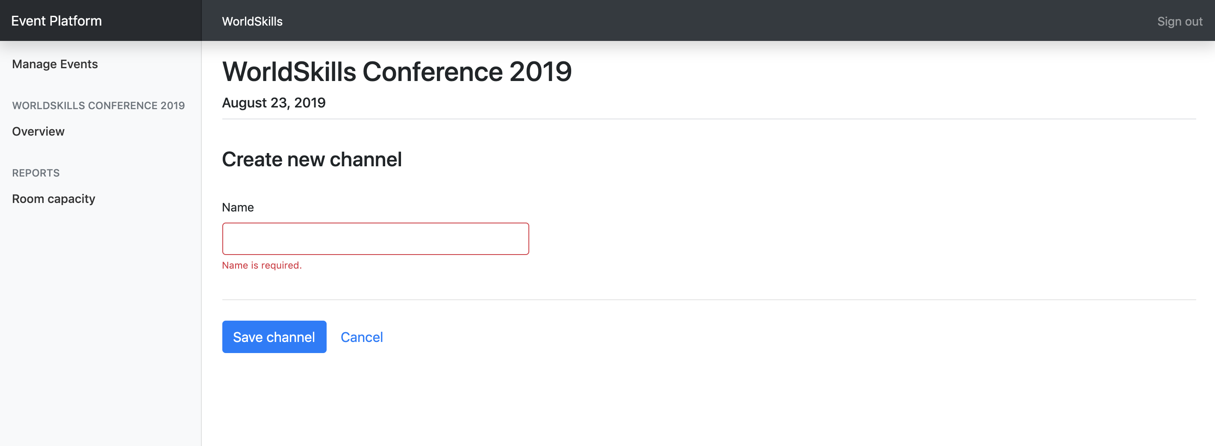

Scenario: A5b – Enter information for a new channel
场景：A5b–输入新频道的信息
Given a form to enter channel information is shown
假设显示了一个输入频道信息的表单
When I enter information for the channel (all fields required)
当我输入频道信息时（所有字段都是必需的）
And I press "Save channel"
我按下“Save channel”
Then the channel is saved into the database
然后将频道保存到数据库中
And I am redirected to the detail page of the event it is assigned to
我被重定向到它被分配到的事件详细页面上
And a success message "Channel successfully created" is shown
显示成功消息“Channel successfully created”

Room management 房间管理
A room is assigned to exactly one channel and can have exactly one session at a time.
一个房间只分配给一个频道，一次只能有一个活动。
Specification: 规范
Feature: A6 – Manage rooms: As an organizer I want to manage rooms which I can later assign to sessions
功能：A6–管理房间：作为组织者，我希望管理房间，稍后可以将其分配给各活动
Scenario: A6a – Show form for new room
场景：A6a–显示新房间的表单
Given I am on the detail page of an event
假设我在一个事件的详细页面上
And I press "Create new room"
我按“Create new room”
Then a form to enter room information appears
然后会出现一个输入房间信息的表单

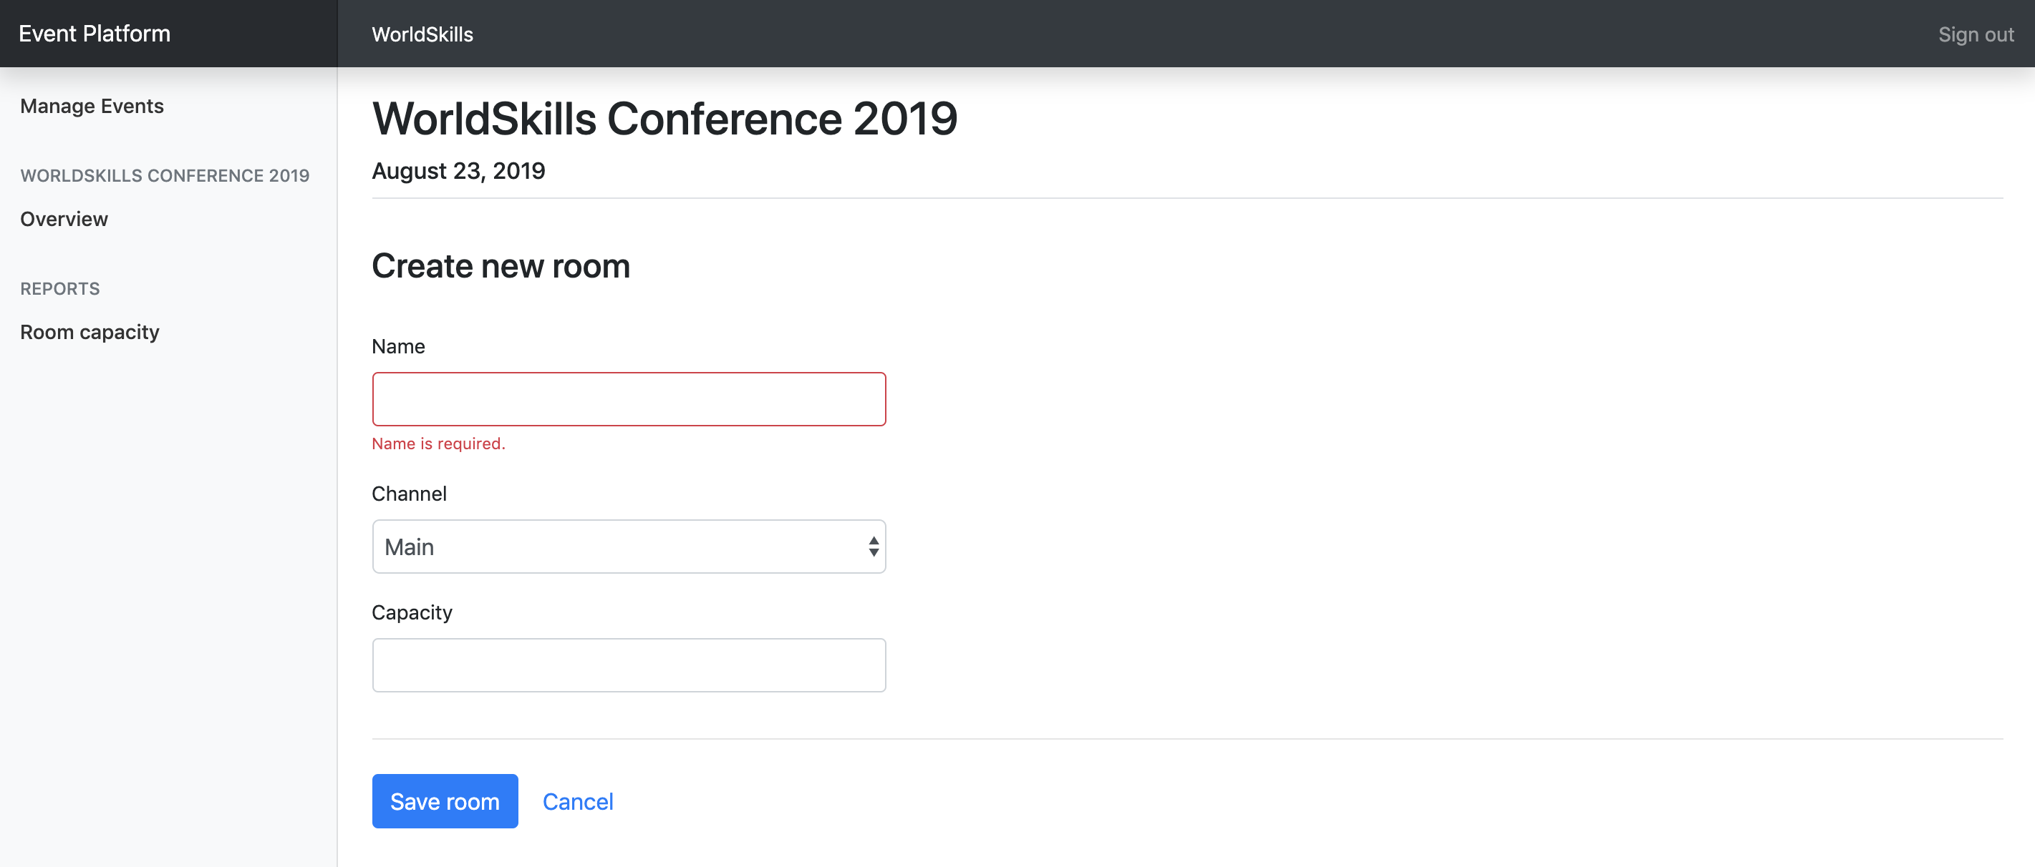

Scenario: A6b – Enter information for a new room
场景：A6b–输入新房间的信息
Given a form to enter room information is shown
假设显示了输入房间信息的表单
When I enter information for the room (all fields required)
当我输入房间信息时（所有字段都是必需的）
And I press "Save room"
我按下“Save room”
Then the room is saved into the database
然后房间被保存到数据库中
And I am redirected to the detail page of the event it is assigned to
我被重定向到它被分配到的事件详细页面上
And a success message "Room successfully created" is shown
并显示成功消息“Room successfully created”（房间创建成功）

Room capacity 房间容量
Organizers want to see an overview of all sessions with information about the room capacity and number of attendees. With this information, they can see if a room is reaching its full capacity.
组织者希望查看所有活动的概况，其中包含有关房间容量和与会者数量的信息。通过这些信息，他们可以看到房间是否达到最大容量。
Please note that for all sessions of type talk, attendees don't need a separate ticket. For sessions of type workshop, they need a separate ticket.
请注意，对于talk类型的所有活动，与会者不需要单独的门票。对于workshop类型的所有活动，他们需要一张单独的门票。
Specification: 规范
Feature: A7 – Room overview: As an organizer I want to see an overview of the sessions with the room capacity and number of attendees
功能：A7–房间概况： 作为组织者，我想了解房间容量和与会者人数的概况。
Scenario: A7a – Show room overview
场景：A7a–展厅概况
Given I am on the detail page of an event
假设我在一个事件的详细页面上
When I press the link "Room capacity" in the sidebar
当我按下侧边栏中的“Room capacity”链接时
Then I see a bar chart displaying sessions along the horizontal axis,
while the y-axis is showing the room capacity superimposed with the
registered amount of attendees
然后我看到一个条形图显示沿水平轴的活动，而Y轴显示房间容量及与参会注册人数

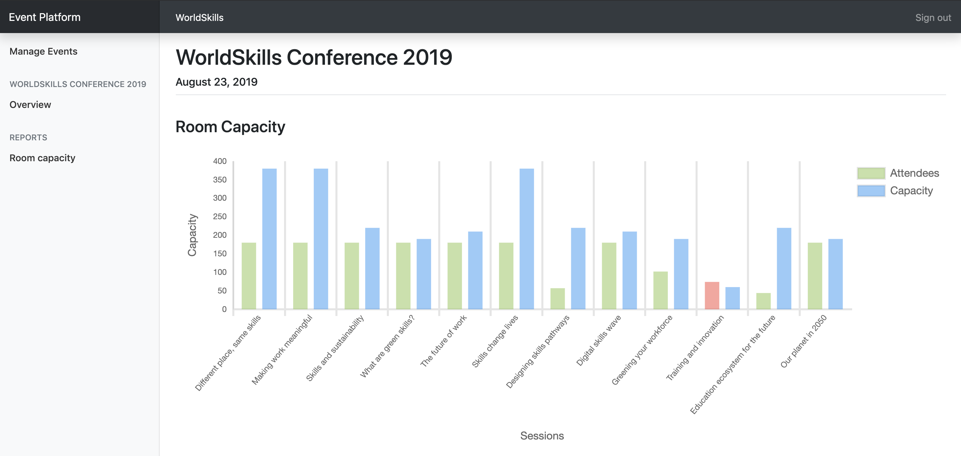

Scenario: A7b – Room capacity exceeded
场景：A7b–超出房间容量
Given I am on the "Room capacity" page
假设我在“房间容量”页面上
When I have a room which exceeds its capacity
当我的房间超过它的容量时
Then I see the visitors bar highlighted with a red color instead of green
然后我看到访客栏用红色而不是绿色突出显示。

Attendee API 与会者API
Create a RESTful API (http://<hostname>/XX JS-PHP A/api/v1/…) to
创建一个RESTful API（http://hostname>/XX JS-PHP A/api/v1/…）用于
- login and logout as an attendee
- 以与会者身份登录和注销
- read all upcoming events
- 阅读所有即将发生的事件
- see the agenda for an event
- 查看事件议程
- sign up and purchase a ticket for an event
- 报名并购买事件门票

PHPUnit tests PHPUnit测试
Tests for the PHP API are distributed with the mediafiles. Please see the following instructions to set them up and configure on your own server.
PHP API的测试与媒体文件一起分发。请参阅以下说明,并在您自己的服务器上设置和配置它们。
Setup: 设置：
- Upload the API tests to your server
将API测试上传到服务器
- Configure the .env file of the API tests and provide correct database credentials and the URL where your API is available.
配置API测试的.env文件，并提供正确的数据库凭据和API可用的URL。
Running the tests: 运行测试：
Execute the following command on the server inside the directory of the api tests:
在api测试目录内的服务器上执行以下命令：
composer test 编写器测试
To only run a single test, you can use the following command for example:
为了仅运行单个测试，您可以使用以下命令，例如：
composer test -- --filter B2EventDetailTest
编写器测试---filter B2事件详情测试
Additional information for the REST-API tests/specification: the body contains some static example data, adjust it to fit the requirements. Placeholder parameters in the URL are marked with curly braces:
有关REST-API测试/规范的附加信息：主体包含一些静态示例数据，请根据要求对其进行调整。URL中的占位符参数用大括号标记：{slug}
The tests are referenced by its function name [-> test<scenario-id><text>].
测试由其函数名[->test<scenario id><text>]引用
The order of properties in objects does not matter, but the order of items in an array does.
对象中属性的顺序无关紧要，但数组中项目的顺序很重要。

Events overview事件概述
When an attendee lands on the index page of the application, he will get a list with all upcoming events across all organizers. Events should be ordered ascendilgly by their date.
当与会者登录到应用程序的索引页时，他将得到一个包含所有组织者即将发生的事件列表。事件应该按日期升序排列。
Specification: 规范
Feature: B1 – Read events: As a visitor I want to read the public data of all upcoming events so that I can display them in a list
功能：B1–读取事件：作为访问者，我希望读取所有即将发生事件的公共数据，以便我将其显示在列表中
Scenario: B1a – Read all upcoming events
场景：B1a–读取所有即将发生的事件
Request
URL: /api/v1/events
Method: GET
Header:
Body: -
Response
If success [-> testB1aGetEvents]
Header: Response code: 200
Body: {"events": [{"id": 1, "name": "someText", "slug": "some-text", "date": "2019-08-15", "organizer": {"id": 1, "name": "someText", "slug": "some-text"}}]}

Event detail 事件详细信息
When an event is selected, all information of the selected event should be returned in the same endpoint.
选择一个事件时，所选事件的所有信息都应返回到同一端点。
If a session has no cost or a ticket no description, NULL will be used.
如果某活动没有成本或门票没有说明，将使用空值。
The description of a ticket is generated as following:
门票的描述生成如下：
- NULL if no special validity rule set
- 如果没有设置特殊的有效性规定，则为空
- "Available until {month} {day}, {year}" if special validity rule "date" is used
(example: "Available until September 1, 2019")
- “Available until {month} {day}, {year}”，如果使用特殊有效性规定“date”
（示例：“2019年9月1日前可用”）
- "X tickets available" if special validity rule "amount" is used
(example: "30 tickets available" where 30 is the total amount of tickets and not the remaining ones)
- 如果使用特殊有效性规定“amount”，“x票可用”
（示例：“30张可用票”，其中30张是总票数，而不是剩余票数）

Specification: 规范
Feature: B2 - Read event: As a visitor I want to read all information about an event
功能：B2-读取事件：作为访问者，我想读取有关事件的所有信息
Scenario: B2a – Read all detail information of a single event
场景：B2a–读取单个事件的所有详细信息
Request
URL: /api/v1/organizers/{organizer-slug}/events/{event-slug}
Method: GET
Header:
Body: -
Response
If success [-> testB2aGetEventDetail | testB2aTicketValidity]
Header: Response code: 200
Body: {"id": 1, "name": "someText", "slug": "some-text", "date": "2019-08-15", "channels": [{"id": 1, "name": "someText", "rooms": [{"id": 1, "name": "someText", "sessions": [{"id": 1, "title": "someText", "description": "someText", "speaker": "someText", "start": "2019-08-15 10:00:00", "end": "2019-08-15 10:45:00", "type": "workshop", "cost": 50|null}]}]}], "tickets": [{"id": 1, "name": "someText", "description": "Available until July 7, 2019"|null, "cost": 199.99, "available": true}]}
If event does not exist or was not created by the organizer [-> testB2aGetInvalidEvent]
Header: Response code: 404
Body: {"message": "Event not found"}
If organizer does not exist [-> testB2aGetInvalidOrganizer]
Header: Response code: 404
Body: {"message": "Organizer not found"}

Attendee login and logout 与会者登录和注销
After signup (which is not within the scope of this project), attendees get assigned a random 6 characters long registration code which they need when entering an event. To avoid requiring yet another password, this registration code is also used for logging the user in on the website, together with his lastname as his login credentials. The registration code is shared across all events and is not only valid for a single event.
注册后（不在本项目范围内），与会者将被随机分配一个6个字符长的注册码，这是他们在进入事件时需要的。为了避免需要另一个密码，此注册代码还将用于用户登录网站，并将其姓氏作为登录凭据。注册代码在所有事件之间共享，而不仅仅只对单个事件有效。
For testing purposes, the registration code and last name can be seen in the database dump.
出于测试目的，可以在数据库转储中看到注册代码和姓氏。
On a successful login, data of the loggedin attendee gets returned together with a token which can be sumitted with subsequent requests. For simplicity, the token is the username md5-hashed and is valid until the logout endpoint is called.
登录成功后，与会者的登录数据将与一个令牌一起返回，该令牌可与后续请求一起提交。为了简单起见，令牌是md5散列的用户名，并且在调用注销端点之前是有效的。
Specification: 规范
Feature: B3 - Login and Logout as atteendee: As a visitor I want to login/logout so that I can attend an event and see my registrations
功能：B3 - 以与会者身份登录和注销：作为访问者，我希望登录/注销，以便我可以参加事件并查看我的注册信息。
Scenario: B3a - Attendee login
场景：B3a-与会者登录
Request
URL: /api/v1/login
Method: POST
Header:
Body: {"lastname": "someText", "registration_code": "someText"}
Response
If success [-> testB3aCorrectLogin|SameLastname|SameRegistrationCode]
Header: Response code: 200
Body: {"firstname: "someText", "lastname": "someText", "username": "someText", "email": "someText", "token": "AUTHORIZATION_TOKEN"} (md5 hashed username, valid until logout)
If user login info not correct [-> testB3aInvalidLastname|RegistrationCode|Request]
Header: Response code: 401
Body: {"message": "Invalid login"}

Scenario: B3b – Attendee logout
场景：B3b-与会者登出
Request
URL: /api/v1/logout?token={AUTHORIZATION_TOKEN}
Method: POST
Header:
Body: -
Response
If success [-> testB3bLogout]
Header: Response code: 200
Body: {"message": "Logout success"}
If invalid token [-> testB3bInvalidToken | testB3bAlreadyLoggedOut]
Header: Response code: 401
Body: {"message": "Invalid token"}

Event registration事件注册
Users will register and buy a ticket with this endpoint. The different ticket validity rules (date or amount) should be validated. Registrations should be sorted ascendingly by their id.
用户将在此端点注册并购买门票。应验证不同的门票有效性规定（日期或金额）。注册应按其ID升序排列。
Specification: 规范
Feature: B4 – Event registration: As a visitor I want to register for an event
功能：B4–事件注册：作为访客，我想注册事件
Scenario: B4a – New event registration
场景：B4a–新事件注册
Request
URL: /api/v1/organizers/{organizer-slug}/events/{event-slug}/registration?token={AUTHORIZATION_TOKEN}
Method: POST
Header:
Body: {"ticket_id": 1, "session_ids": [1, 2, 3]} (session_ids is optional)
Response
If success [-> testB4aCorrectRegistration]
Header: Response code: 200
Body: {"message": "Registration successful"}
If user is not logged in or token is invalid [-> testB4aLoggedOut]
Header: Response code: 401
Body: {"message": "User not logged in"}
If user already registered for this event [-> testB4aAlreadyRegistered]
Header: Response code: 401
Body: {"message": "User already registered"}
If ticket is not available anymore [->testB4aInvalidTicket]
Header: Response code: 401
Body: {"message": "Ticket is no longer available"}

Scenario: B4b – Get registrations of a user
场景：B4b–获取用户的注册
Request
URL: /api/v1/registrations?token={AUTHORIZATION_TOKEN}
Method: GET
Header:
Body: -
Response
If success [-> testB4bGetRegistrations | testB4bNewRegistration]
Header: Response code: 200
Body: {"registrations": [{"event": {"id": 1, "name": "someText", "slug": "some-text", "date": "2019-08-15", "organizer": {"id": 1, "name": "someText", "slug": "some-text"}}, "session_ids": [1, 2, 3]}]}
If user is not logged in or token is invalid [-> testB4bLoggedOut]
Header: Response code: 401
Body: {"message": "User not logged in"}

Phase two – JavaScript 第二阶段 Javascript

API Setup API设置
The API needed for this part will be provided after lunch and can be set up with the following instructions. In case you want to start with part two before lunch, you have to use your own API from part one.
此部分所需的API将在午餐后提供，并可按照以下说明进行设置。如果您想在午餐前从第二部分开始，您必须使用第一部分中自己的API。
Automated setup: 自动设置
Connect to your server through SSH and execute the following command (in your home directory):
通过SSH连接到服务器并执行以下命令（在主目录中）：
setup-api
This will automatically set up the API and database on your server. After completion, the API is available at http://XX.skill17.com/day2-afternoon (XX is your workstation number).
这将自动在服务器上设置API和数据库。完成后，API可在http://xx.skill17.com/day2-afternoon获得（xx是您的工位号）。
The API is implemented according to the specification of the Attendees API in part one.
API是根据与会者在第一部分的API规范中实现的。
Manual setup:
手动设置：
The manual setup should only be done in case the automatic setup fails.
只有在自动设置失败的情况下才能进行手动设置。
- Download the API from http://wsi.skill17.com/day2_afternoon_api.zip(only available in the afternoon)
从http://wsi.skill17.com/day2_afternoon_api.zip下载API（仅在下午可用）
- Upload it to your server and unzip it into the folder /home/competitor/www/day2-afternoon (ensure that the unzipped files files are directly located in the folder /home/competitor/www/day2-afternoon and not in another subfolder)
将其上传到您自己的服务器上并解压缩到文件夹/home/competitor/www/day2-afternoon（确保解压缩的文件直接位于文件夹/home/competitor/www/day2-afternoon，而不是另一个子文件夹中）
- Create a new database called day2 afternoon and import the provided dump from part one
创建一个名为day2 afternoon的新数据库，并从第一部分导入所提供的转储文件。
- The API is now available at http://XX.skill17.com/day2-afternoon (XX is your workstation number)
API现在在http://xx.skill17.com/day2-afternoon上可用（xx是您的 工位号）

Introduction 介绍
Using the RESTful API (all data coming/going into database), create a frontend for attendees to browse information about the events, login/logout and register for an event. During registration, it should be possible to add additional workshops they want to attend.
使用RESTful API（所有进入/出入数据库的数据），创建一个前端，供与会者浏览事件信息、登录/注销和注册事件。在注册期间，应该可以增加他们想参加的其他研讨会。
The RESTful API supports POST requests with JSON or FormData bodies, but the correct request headers need to be set accordingly to the used body type.
RESTful API支持带有JSON或FormData主体的POST请求，但是需要根据所使用的主体类型相应地设置正确的标头信息。
Interaction should show error/feedback messages based on response from the API where appropriate. Also, an error page should be shown when accessing an invalid URL.
在适当的情况下，交互应该根据API的响应显示错误/反馈消息。此外，访问无效的URL时应显示错误页。
Browsing all data is public and no user is required. But as soon as they want to register for an event, they need to be signed in.
浏览所有数据是公开的，不需要用户。但一旦他们想要注册一个事件，他们就需要登录。
Refreshing a page should always display the same page and it must be possible to share a page by URL so that all state is kept in the URL.
刷新页面应始终显示相同的页面，并且必须能够按URL共享页面，以便所有状态都保持在URL中。
The layout should follow mockups exactly. The position of elemenst in design should be same as mockups.
布局应该完全遵循模型。元素在设计中的位置应与模型相同。
The yellow bubbles in the mockups show classes and ids which have to be used for those elements to allow running automated tests. The yellow bubbles are not part of the design and do not have to be displayed in the browser.
模型中的黄色气泡显示分类和ID，这些分类和ID必须用于那些允许运行自动测试的元素。黄色气泡不是设计的一部分，不必在浏览器中显示。
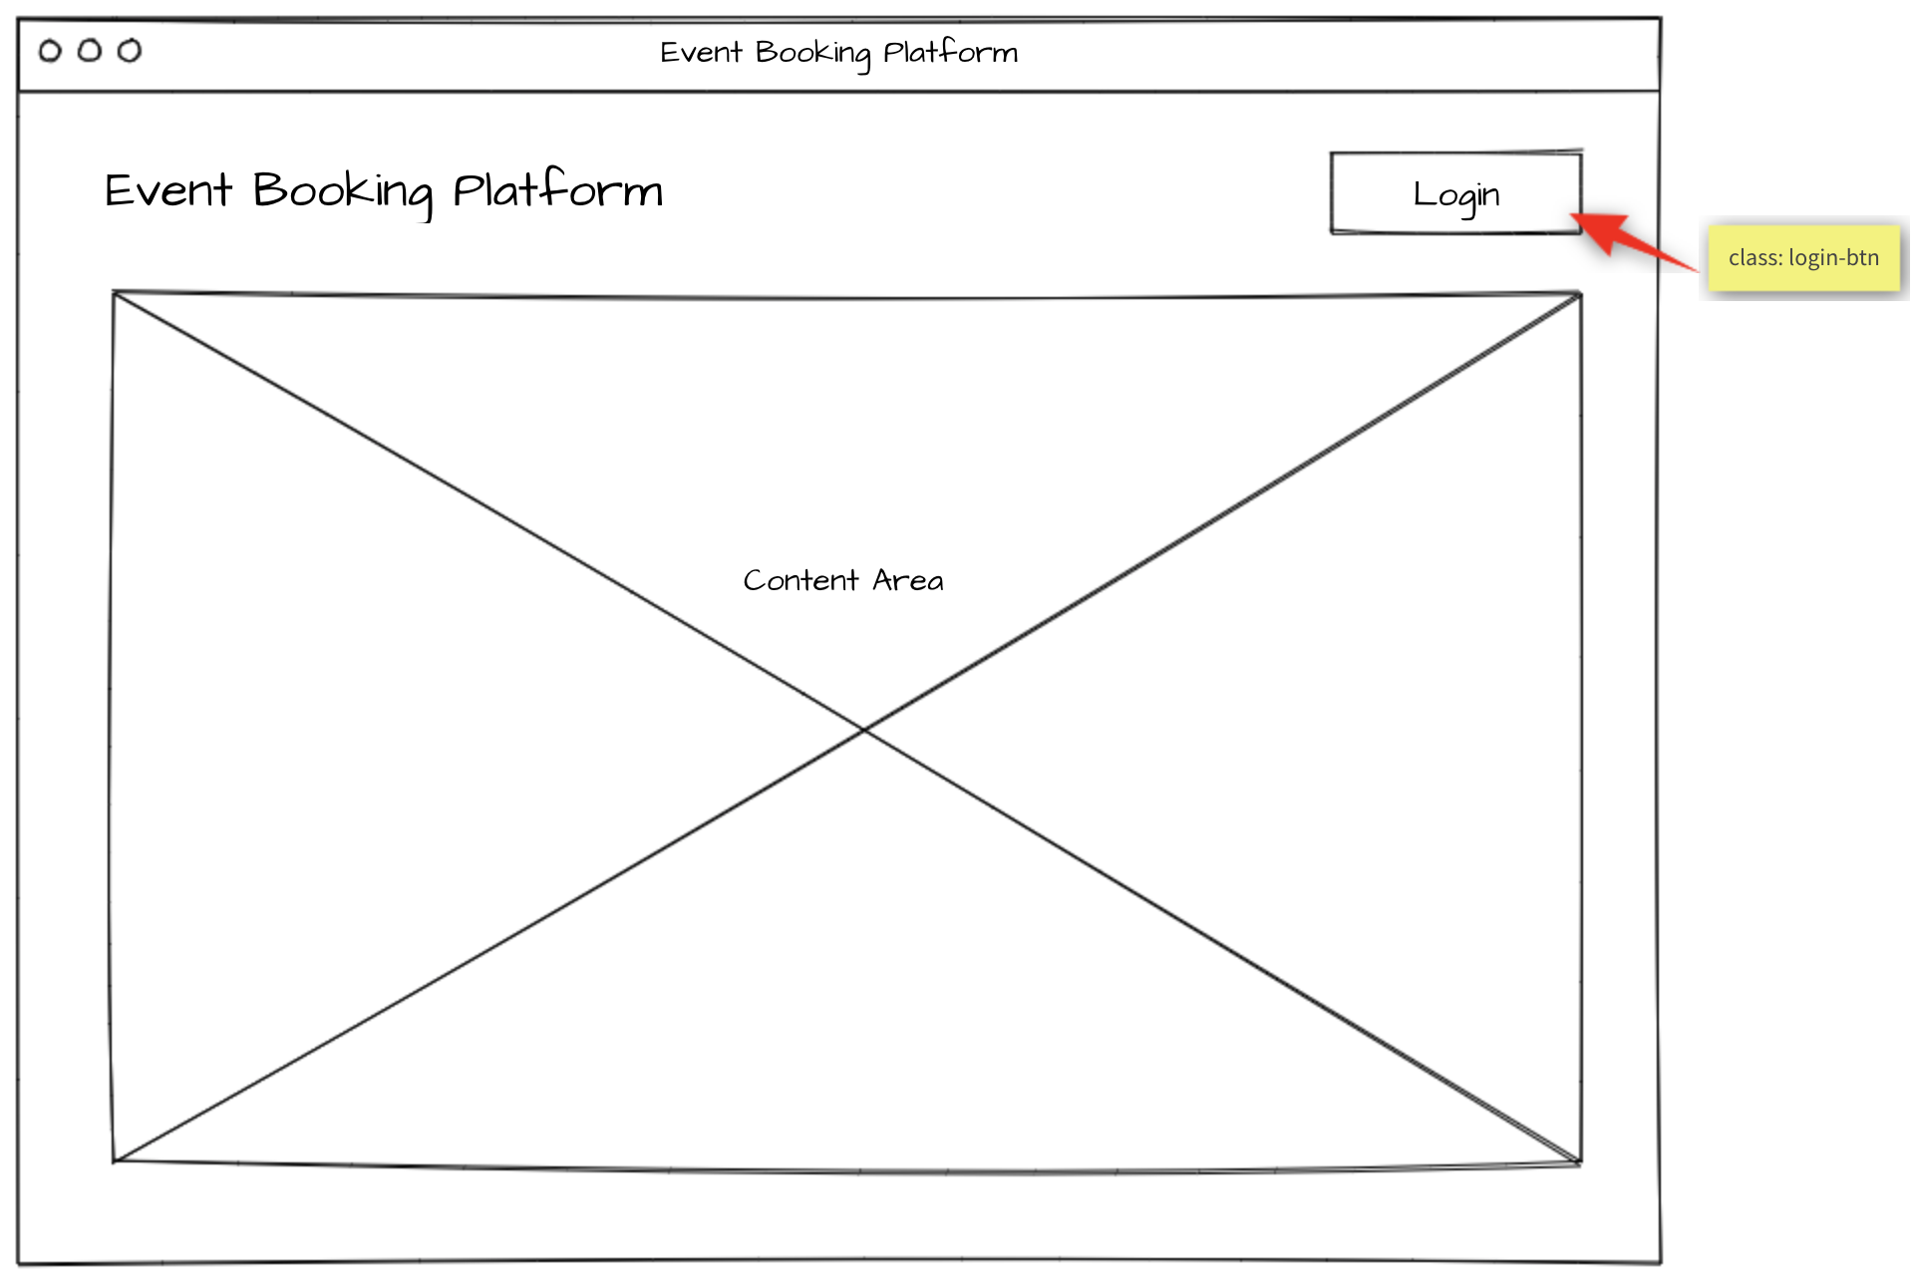

Events list 事件列表
When accessing the index page, all upcoming events are displayed with their organizer name and the date it takes place. By selecting an event, the event agenda will be shown.
访问索引页时，将显示所有即将发生的事件及其组织者的名称和发生日期。通过选择事件，将显示事件议程
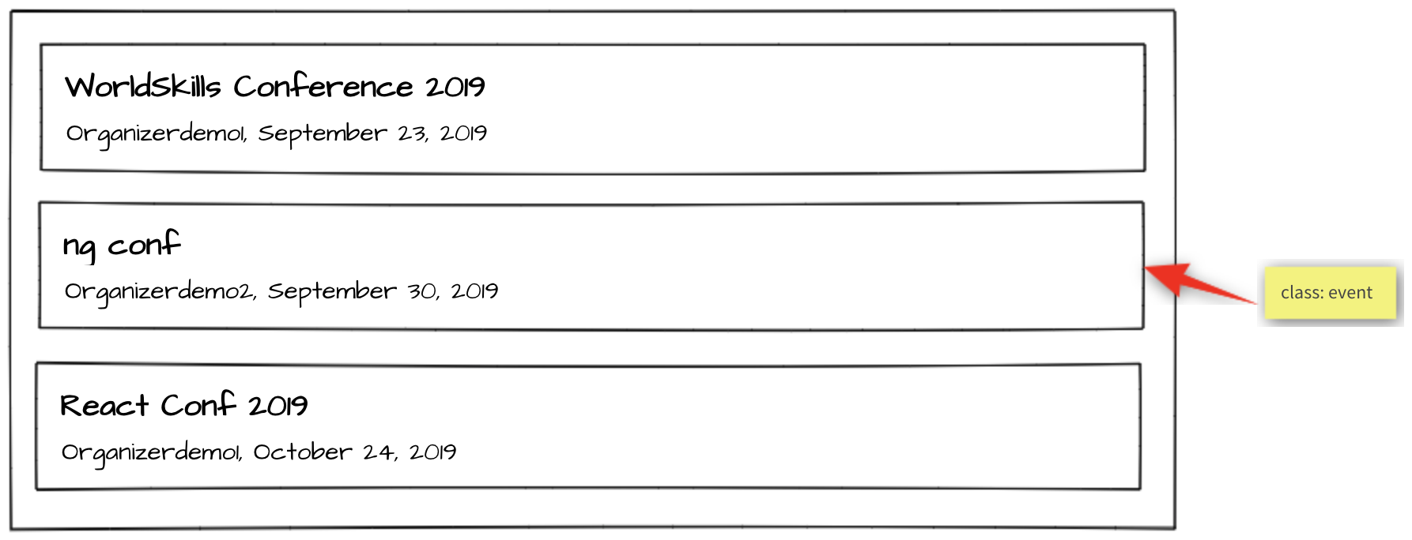
Specification: 规范
Feature C1 - List upcoming events: As an attendee, I want to see what events I can attend.
功能C1-列出即将举行的事件：作为与会者，我想看看我可以参加哪些事件。
Scenario: C1a - List upcoming events
场景：C1a-列出即将发生的事件
Given I am on the home page
假设我在主页上
Then I see a chronologically ordered list of upcoming events across all
Organizers
那么我会看到一个按时间顺序排列的所有组织者即将举办的事件列表
And I can click on an event
我可以单击一个事件

Event agenda 事件议程
The agenda of the selected event is shown. If the user is logged in and is already registered for this event, all sessions with type talk are highlighted with a green border since they are automatically included in every event registration. Additionally, if the user signed up for addition sessions of type workshop, they will also be highlighted with a green border.
所选的事件议程将被显示。如果用户已登录并已注册此事件，则所有talk类型的活动都将突出显示为绿色边框，因为它们将自动纳入每个事件注册中。此外，如果用户报名了Workshop类型的附加活动，那么它们也同样将以绿色边框突出显示。
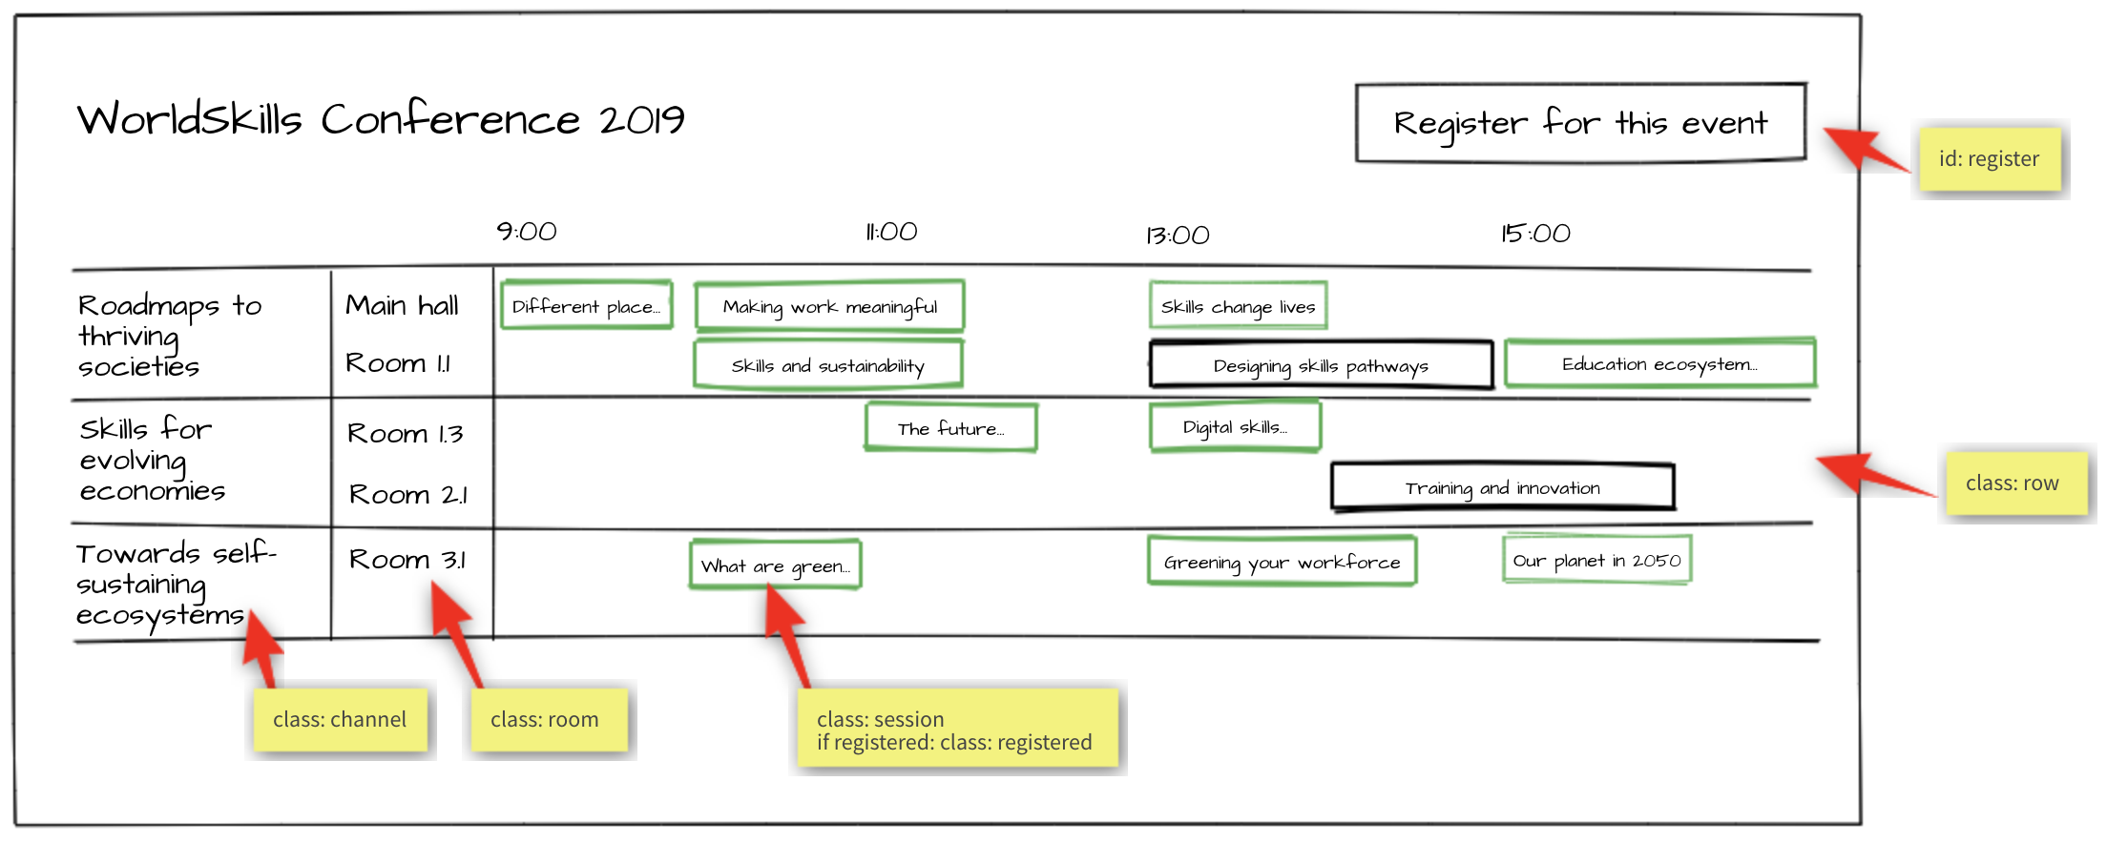
Specification: 规范
Feature C2 - Display event agenda: As an attendee, I want to see what sessions are within an event.
功能C2-显示事件议程：作为与会者，我想看看事件中有哪些活动。
Scenario: C2a - Display channels
场景：C2a-显示频道

Given I am on an event detail page
假设我在一个事件详细信息页面上
Then I see the channels of the event forming horizontal swimlanes
And the channels contain the rooms as "inside"-swimlanes
那么我看到了以水平泳道图展示的事件中的频道，并且在泳道图中展示频道中的房间。
Scenario: C2b - Display talk and workshop sessions
场景：C2b-显示会话和研讨会
Given I am on an event detail page
假设我在一个事件详细页面上
Then I see the timeline containing "9:00", "11:00", "13:00", "15:00"
那么我会看到包含“9:00”、“11:00”、“13:00”、“15:00”的时间线
And I see the sessions in the correct room swimlane starting and ending
at the correct time
并且我看到活动在正确的房间泳道中，并且房间泳道的起止时间也是正确的。

Scenario: C2c - Display registered sessions
场景：C2c-显示已注册的活动
Given I am on an event detail page
假设我在一个事件详细信息页面上
And I am logged in
并且登录
And I am already registered for this event
我已经注册参加了这个事件
Then I see all sessions of type talk highlighted with a green border
然后我看到所有talk（会话）类型的活动都以绿色边框突出显示
And I see all sessions of type workshop which I have signed up for
highlighted with a green border
然后所有我报名参加的wrokshop（研讨会）类型的活动都以绿色边框突出显示。

Session detail 活动详细信息
When clicking on a session within the agenda, a detail page showing all information about this session will be shown.
单击议程中的某个活动时，将显示一个详细页面，其中显示有关该活动的所有信息。
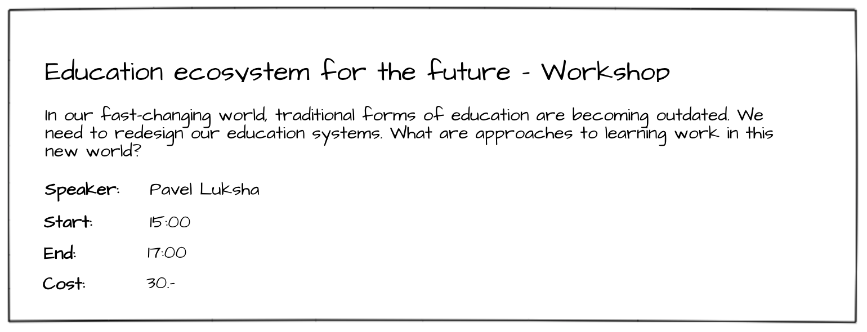
Specification: 规范
Feature C3 - Display session details: As an attendee, I want to inform myself about the details of a session.
功能C3 - 显示活动详细信息：作为与会者，我想通知自己活动的详细信息。
Scenario: C3a - Display session details
场景：C3a-显示活动详细信息
Given I am on an event detail page
假设我在活动详情页面
When I click on a session
当我单击某个活动时
Then I see a detail page of the session containing title, description,
speaker, start and end time, type and the cost (if it is set)
我会看到该活动的详细页面，其中包含标题、说明、演讲者、起止时间、类型和成本（如果已设置）。

Event registration 事件注册
After clicking on "register for this event", the user either sees the event registration form if he is logged in or gets redirected to the login form if he is not logged in.
单击“注册此事件”后，如果用户已登录，则会看到事件注册窗体；如果用户未登录，则会重定向到登录窗体。
On the event registration form, he can select the ticket type he wants. Unavailable tickets are greyed out and can't be selected. The API is responsible for this information and the validation, so it does not have to be handled in the frontend.
在事件注册表上，他可以选择他想要的门票类型。不可用的门票已灰显，无法选择。API负责这些信息和验证，因此不必在前端处理它。
The user can also select additional sessions of type workshop he wants to attend. If a session has an additional cost, it will show up in the cost view and add to the total cost.
用户还可以选择他想参加的workshop(研讨会)类型的附加活动。如果活动有附加成本，它将显示在成本视图中并添加到总成本中。
After clicking on "Purchase", the user will be registered for this event and the sessions he has selected and gets redirected back to the event detail page.
单击“购买”后，用户将注册此事件和他所选择的活动，并被重定向到事件详细信息页面。
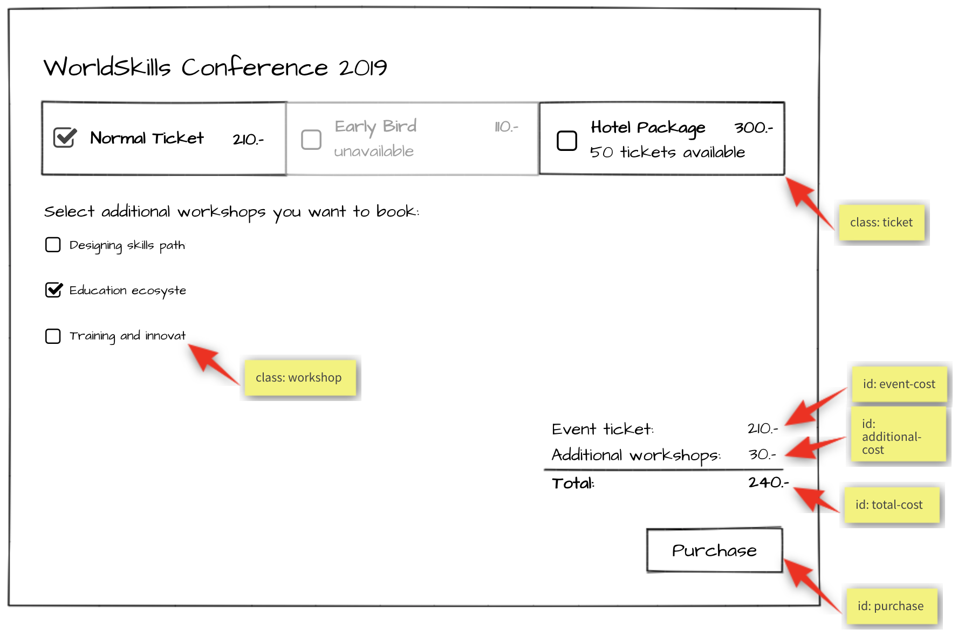

Specification:规范
Feature: C4 - Register for event: As an attendee, I want to be able to register for an event and pay the admission fee.
功能：C4-注册事件：作为一名与会者，我想能够注册一个事件，并支付入场费。
Scenario: C4a - Enter registration mode
场景：C4a-进入注册模式
Given I am on an event detail page
假设我在活动详情页面上，
And I am logged in
我已经登录，
Then I can click on a button to enter registration mode
然后我单击一个按钮进入注册模式。
And I see the ticket types and their cost
我看到了门票的类型和成本
And I see a checkbox list of sessions of type workshop
我看到一个workshop(研讨会)类型的活动复选框列表
And I see a cost view summary
我看到一个成本视图摘要
And I see a disabled "Purchase" button
我看到一个禁用的“Purchase”按钮

Scenario: C4b - Select ticket success
场景：C4b-选择门票成功
Given I am in registration mode of an event
假设我在一个事件中处于注册模式
When I select a ticket that is available
当我选择一张可用的门票时
Then the ticket cost is displayed in the cost view summary
然后，门票成本显示在成本视图摘要中
And the "Purchase" button is enabled
“Purchase” 按钮是可用的

Scenario: C4c - Select ticket fail
场景：C4c-选择门票失败
Given I am in registration mode of an event
假设我在一个事件中处于注册模式
When I select a ticket that is not available
当我选择一张不可用的门票时
Then the ticket is not selected
门票不能被选定
And the "Purchase" button is not enabled
“Purchase” 按钮不可用
Scenario: C4d - Select workshop session
场景：C4d-选择研讨会活动
Given I am in registration mode in an event
假设我在一个事件中处于注册模式
When I tick a workshop session
当我在研讨会活动上打勾时
Then the session receives a tick
然后活动会收到一个勾号
And the price of the workshop is displayed under "Additional workshops" in
in the cost view
研讨会的价格显示在“Additional workshops”的成本视图下
And the price of the session is added to the total cost
活动的价格加在总价上

Scenario: C4e – Purchase
场景：C4e-购买
Given I am in registration mode in an event
假设我在一个事件中处于注册模式
When I select a ticket and I press the "Purchase” button
当我选择一张门票并按下“Purchase”按钮时
Then the registration is saved
然后注册就被保存了
And I get redirected to the event agenda
我被重定向到事件议程
And a message appears "Registration successful"
出现一条信息“Registration successful”

Attendee login 与会者登录
When registering for an event, a login is required. After a successful login, the login button in the navigation should no longer be visible. Instead, the username of the currently logged in user should be displayed and a button to log out.
注册事件时，需要登录。成功登录后，导航中的“登录”按钮将不再可见。相反，应该显示当前登录用户的用户名和注销按钮。
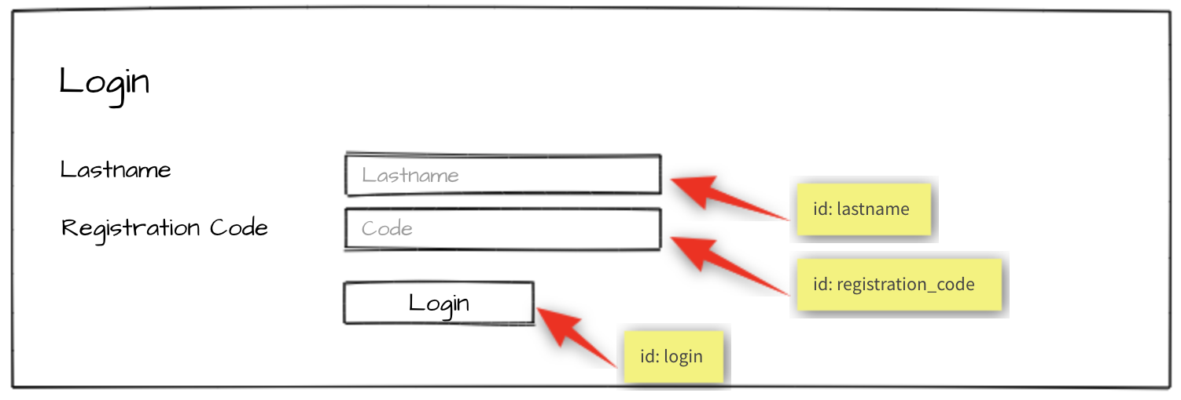
Specification: 规范
Feature: C5 – Log in and log out as an attendee: As an attendee, I would like to log in and log out to the event
platform so that I can access my registrations and register for new events.
功能：C5–以与会者身份登录和注销：作为与会者，我想登录和注销该事件平台，以便访问我的注册并注册新事件。
Scenario: C5a - Attendee login ok
场景：C5a-与会者登录确定
Given I am on the "login" page
假设我在“登录”页面
When I enter the specified lastname and registration code for an attendee
当与会者输入详细的姓氏和注册代码时
And press the "Login" button
按下“Login”按钮
Then I'm forwarded to the previous page
然后会转到上一页
And username and "Logout" button become visible in the header
用户名和“Logout”按钮在标头中可见

Scenario: C5b - Attendee login fail
场景：C5b-与会者登录失败
Given I am on the "login" page
假设我在“login”页面
When I enter a wrong lastname and registration code for an attendee
当与会者输入错误的姓氏和注册代码时
And press the "Login" button
按下“Login”按钮
Then I stay on the "login" page
然后我停留在“login”页面
And I see an error message "Lastname or registration code not correct"
会出现一条错误消息“Lastname or registration code not correct”

Scenario: C5c - Attendee logout
场景：C5c-与会者注销
Given I am logged in
假设我登录了
When I press the "Logout" button
当我按下“Logout”按钮时
Then I am forwarded to the "login" page
我被转到“login”页面
And username and logout button disappear
用户名和注销按钮消失
And I cannot reach the previous page by going back
我无法返回上一页

Notes 提示
- When you are done with the first phase resp. after lunch you may continue with the second phase.
- 完成第一阶段后。午餐后，您可以继续第二阶段
- If you are done with part one before the lunch break, you can start with part two by using your own API and exchange it at the start of the afternoon with the provided API.
- 如果您在午餐前完成了第一部分，您可以从第二部分开始，使用自己的API，并在下午开始时与提供的API进行交换。
- Competitors must use one of the server-side and client-side frameworks/libraries that are provided.
- 选手必须使用所提供的服务器端和客户端框架/库之一。
- The provided template for the admin interface should be used. It can be enhanced to get better functionality for your site. The visual design of the admin interface will not be assessed. 应使用为管理界面提供的模板。它可以增强以获得更好的网站功能。管理界面的可视化设计不会被评估。
The design of the attendee interface can be based on the template of the admin interface. The visual design of the attendee interface will be assessed: a simple, clean and attractive design is expected including choice of colors, typography and spacing.
The design should be optimized for a minium window width of 1024px. 与会者界面的设计可以基于管理界面的模板。将对与会者界面的视觉设计进行评估：设计简单、干净、美观包括颜色、排版和间距的选择。设计应优化为最小窗口宽度1024px。
- For the admin interface it is important to use the selectors (class, id) as provided in the template. For the attendee interface it is important to use the selectors (class, id) as specified in the screen mockup (yellow bubbles). 对于管理界面，重要的是使用模板中提供的选择器（Class、ID）。对于与会者界面，重要的是使用屏幕模型（黄色气泡）中指定的选择器（Class，ID）
- The specified database tables need to be implemented as provided. More tables may be added if needed. The given tables must not be changed. Provide a final SQL-dump and ERD screen as specified below.
- 需要按规定应用指定的数据库表。如果需要，可以添加更多表。不能更改给定的表。按照下面的规定提供最终的SQL转储和ERD屏幕。
- The API implementation should fulfill all requirements as stated in the description. All prefixes, RESTful-URLs and HTTP-Methods from the given API links must be implemented correctly and cannot be changed.
- API的实施应满足说明中所述的所有要求。给定API链接中的所有前缀、RESTful URL和HTTP方法必须正确实现，并且不能更改
- Changes made in the data need to be propagated between frontend and backend in both directions.
- 数据更改需要在前端和后端之间双向传播
- Update the first two organizers in the provided dump so it is possible to login to the system during assessment:
- 更新所提供转储的前两名组织者，以便在评估期间登录系统
  - Organizer accounts: 组织者账号
    - Email: demo1@worldskills.org Password: demopass1
    - Email: demo2@worldskills.org Password: demopass2
- For the room capacity bar chart, you can use one of the provided JS-libraries (Charts.js, D3.js)
- 对于房间容量条形图，可以使用所提供的JS库之一（charts.js、d3.js）

Submission Instructions to the Competitor

选手提交说明
Morning: Files to be collected after the first phase on the server:
上午：在第一阶段之后服务器上要收集的文件
- Web service (http://<hostname>/XX_JS-PHP_A/api/v1/..)
- Web服务（http://<hostname>/xx_js-php_a/api/v1/）
- Admin area (http://<hostname>/XX_JS-PHP_A/) - initially shows login page
- 管理区域（http://<hostname>/xx_js-php_a/）-最初显示登录页面
- Folder inside webroot (XX_JS-PHP_A/)
- webroot中的文件夹（xx_js-php_a/）
- ERD screenshot named “XX_ERD.png” in “db-dump” folder inside of XX_JS-PHP_A
- 名为“XX_ERD.png”的erd屏幕截图，位于xx_js-php_a的“db dump”文件夹中。
- Database dump named “XX_database.sql” in “db-dump” folder inside of XX_JS-PHP_A
- 数据库转储名为“xx_database.sql”，位于XX_JS-PHP_A的“db dump”文件夹中

Afternoon: Files to be collected after the second phase on the server:
下午：在第二阶段之后服务器上要收集的文件：
- Front-end website (http://<hostname>/XX_JS-PHP_B/)
- 前端网站（http://<hostname>/xx_js-php_b/）
- Folder inside webroot (XX_JS-PHP_B/) - put all development files into XX_JS-PHP_B_dev.zip and leave only files for production-use in this directory.
- webroot（xx_js-php_b/）中的文件夹-将所有开发文件放入xx_js-php_b_dev.zip，并在此目录中只保留用于制作的文件。
- If the front-end root (http://<hostname>/XX_JS-PHP_B) does not open the main page directly, have it open an index.html with a link to the main page for marking your front-end.
- 如果前端根目录（http://<hostname>/xx_js-php_b）没有直接打开主页，请让它打开一个index.html，其中包含指向主页的链接，用于标记前端。
XX is your country code
XX是您的国家代码
The Web Service / REST-API will be assessed with the automated test-framework provided. Additional data may be used to test dynamic behavior.
It is recommended that you run the automated tests for the REST-API after implementing it locally or at least after uploading it to the server. Instructions to setup and use the tests for the API: see README.md in tests_api-php.
Manual assessment of other parts will be done using Google Chrome.

Web服务/ REST-API将通过提供的自动化测试框架进行评估。其他数据可用于测试动态行为。
建议您在本地实现REST-API之后或至少在将其上传到服务器之后为其运行自动测试。安装和使用API测试的说明：请参阅tests_api-php中的readme.md。
其他部分的手动评估将使用Google Chrome完成。

Equipment, machinery, installations, and materials required所需设备、机械、装置和材料
It is expected that all Test Projects can be accomplished by Competitors based on the equipment and materials specified in the Infrastructure List*.
预计所有试题内容都可以由选手根据基础设施清单*中规定的设备和材料完成。
If any equipment or material is required that is not listed in the Infrastructure List, then it has to be listed here (in the table below - column headings may vary from skill to skill.)
如果需要基础设施列表中未列出的任何设备或材料，则必须在此列出（在下表中-列标题可能因技能而异）。
WorldSkills International needs to approve any additional infrastructure requirements that are not listed in the Infrastructure List. Column headings may vary from skill to skill.
世界技能组织需要批准基础设施列表中未列出的任何其他基础设施要求。列标题可能因技能而异。

* (Definition: the Infrastructure List is the equipment, machinery, installations and materials supplied by the host country – it does not include tools and material to be supplied by Competitors and/or Experts)
*（定义：基础设施清单是东道国提供的设备、机械、装置和材料，不包括选手和/或专家提供的工具和材料）
ITEM | description
Media Files媒体文件 | Contains:包含：  - DB dump  - Template files for the admin-gui  - Charts.js & D3.js incl. Documentation  - Files for testing REST-API

Marking Scheme
SECTION | CRITERION | JUDG. MARKS | MEAS. MARKS | TOTAL
C1 | Database | 1.75 | 1.5 | 3.25
C2 | Admin Backend | 0 | 3.25 | 3.25
C3 | Ticket and Session | 0 | 1.5 | 1.5
C4 | Organizer | 1 | 2.25 | 3.25
C5 | REST API | 1.5 | 2.25 | 3.75
D1 | Events list and agenda | 0 | 3.75 | 3.75
D2 | Session and Events | 0 | 3 | 3
D3 | General | 1 | 3 | 4
D4 | JS Quality | 2.5 | 0 | 2.5
D5 | Front end design | 3 | 0 | 3
TOTAL |  | 10.75 | 20.5 | 31.25

